UNWANTED NYC PETS 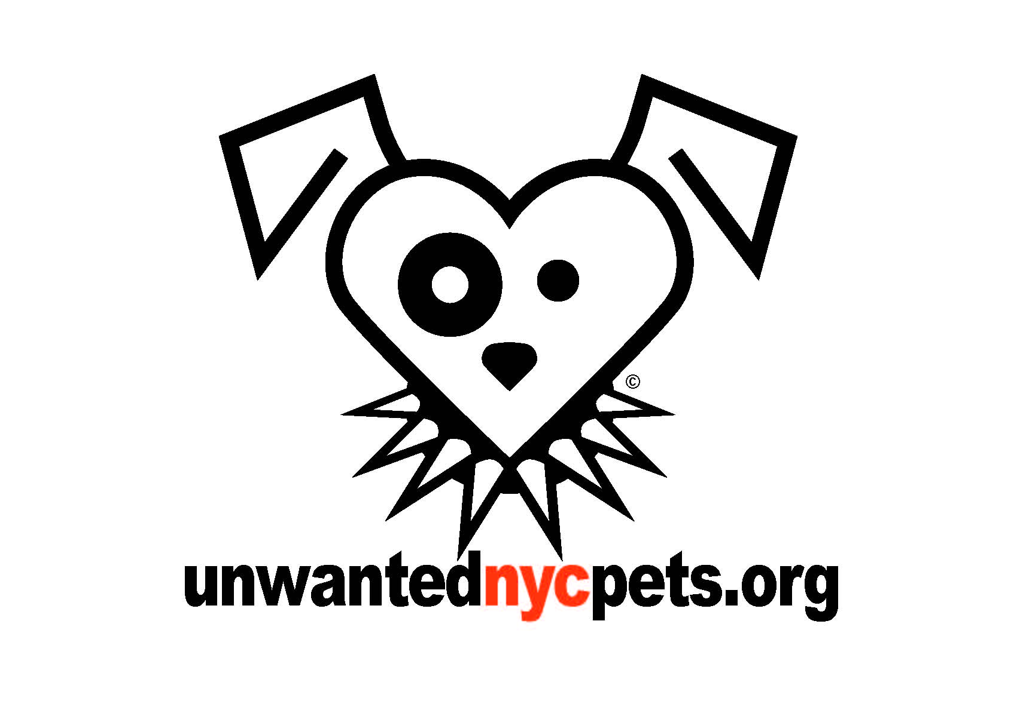
Web: www.unwantednycpets.org
Email: donations@unwantednycpets.org
Facebook Page: Unwanted NYC Pets

Name________________________________________ Date_________________

- How did you find out about Unwanted NYC Pets?

- Do you wish to foster a dog or a cat?

- Size: Small Medium Large

- Are there any breeds you would NOT consider taking?

- Are there any scenarios when you would not want to take a dog?

(Severe injury, pregnant, nippy, not housebroken, leash aggressive)

- Would you take puppies?

- Would you take kittens?

- Would you take cats?

- Are there any cats or kittens you would not take?

(Hissing, pregnant, nursing, injured, feral)

- Do you currently have any pets?

a) Type

b) Male /Female

c) Age

d) Does your pet get along with other dogs/cats/children?

- Are you ready to accept that there can be slight damage to your property?

- Do you suffer from allergies?

- Can you spend quality time with your companion?

- How long are you prepared to Foster?

Additional Comments:

